COMBERBACH WI RAMBLINGS MAY 2020. Edition 1
As we are all finding different ways to get through this extraordinary time, the committee members of Comberbach WI have put together a few little snippets of how we are all adjusting to the lock down time. Hopefully you will enjoy reading about what we have been up to and look forward to you sending back some of your stories of how you have filled your time.
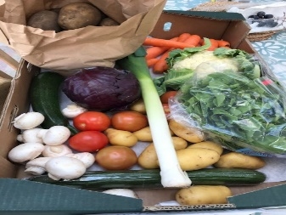
Some local services used by members
Vegetable boxes and 25kg sacks of potatoes are available to order on a weekly basis from Jon - mobile 07921863324
Steve at the Post Office has been very helpful by sourcing a very good range and variety of foods and bedding plants – an extremely valuable local service.
Some of us have secured a regular delivery from Sainsburys and Tesco and have already ordered a few things on behalf of friends and neighbours. We are happy to add the odd item to our order for anyone struggling, but some of the substitutions have been "interesting"! - so can't guarantee anything. Ring Janine on 07756 854042 or Sian on 07770863170 if you need anything and we will try to help. Or e mail sianrc@hotmail.co.uk
----------------------------------------------------------------------------------
Hello from Lindsey
A big thanks to Marbury nursery who delivered these plants. No baskets were done last year because I broke my arm in early May playing Walking Netball.
I hope everyone is doing ok. Let’s hope the sun keep shining. I will let everyone concerned know about the fish and chip tea and the Mousetrap. Please wave if you walk past the end of our drive.
Lindsay
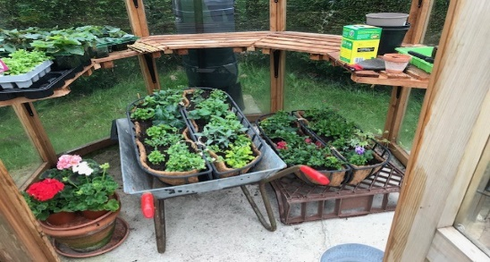

Lindsey’s Hanging baskets ready to go……
Lockdown at 50 Senna Lane, Sara Smith
I have included in this account a picture of the beautiful flowering cherry at the back of our garden which belongs to the school. I don’t know about the rest of you but I have found the spring blossom has been superb this year.
With all this beautiful weather I have managed to finish creating my vegetable patch, plant some seeds and sort out landscaping the rest of the back garden which had been left a mess after we had a patio laid last summer.
I am not much of a cook so I leave the cooking and baking to my husband who is baking bread for the neighbours and making cakes for my son to take to his colleagues at Merseyside police. They love cake.
I have finished the birth sampler for my next grandchild who is expected mid May. Fingers crossed my daughter in law will be OK. I also rushed to the wool shop before lockdown and am knitting a coat for my 3 year old grandson in France and another jumper for his Mum my daughter. She is the only one of my children that likes my knitting. I will send a picture of the finished articles next time. I have also tried to carry on with my art but I am not very good so I may not send a photo of that unless it improves.
I hear other members have been baking and crafting and in view of the fact that we cannot enter the Cheshire Show this year it might be an idea if we had our own little show when we are released. I might even bring some of my paintings!!
I am lucky as are quite a few other members who live with someone and are therefore not on our own. I do not have any health issues particularly so I or my husband can still go out shopping once a week and I can walk quite a long way. I often think of other members I know who are on their own and must be getting a bit stir crazy by now. My thoughts are also with those who have health issues and are limited as to what they can do but I know as WI members you will always be positive.
Keep up the good work, Sara Smith
______________________________________________________
Hello fellow members from Sian
The last few months have been full of highs and lows for me and my family, but I am sure I am not alone when I say that……I am sure we are all going through similar experiences. Whilst the weather has been so amazing – the garden has been a priority and has never looked so neat and tidy, I have even managed to clear the ivy under the beech hedges which has always looked so untidy, but one of those jobs that you keep putting off – well it’s done!
A photo of Jen enjoying the garden and sunshine
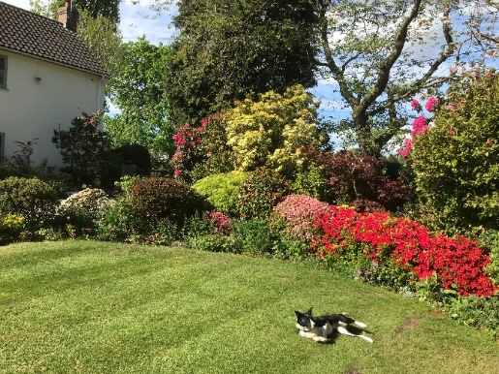
My other great news is the birth of our first grandchild. Rowan was born in New York on the 30th March. Needless to say, our plans to go and spend time with our son and new family have been scuppered, so I am missing spending time with them – and helping with the first few months of sleepless nights and worries.
Here is Rowan along side a large Steiff Teddy – who is the biggest?

Meanwhile I continue to help look after my farmer brother, who is currently staying with us, and we have had to go to his farm in North Wales on a couple of occasions for essential maintenance – and are always rewarded by the beauty of the countryside – and seeing new born lambs and calves.
_________________________________________________
Margery is making the most of being house bound apart from being out in the garden and short walks.
“I am building up my cake selection, in the freezer, so when restrictions are lifted, I am ready for lots of coffee mornings and friends popping in for a chat. “ We will certainly hold you to that Margery! I have defrosted one of my freezers and even cleaned cupboards out.
We are so lucky to live in such a beautiful and caring village. I do miss our meetings and WI activities but being part of the W.I. family certainly has its benefits . Janine ,kindly, has let me share her Sainsbury’s home delivery. It works perfectly and saves my daughter having to go to more than one supermarket.

Photos of Janine’s garden delights – Lilac tree and Wild Garlic found down the tow path a stones throw from Janine’s home.

Recipies for your delight.
Ginger Cake
1/2lb SR flour, 1/2lb golden syrup, 3oz margarine or butter, 2oz demerara sugar, 2 teasp ground ginger, 1 egg, pinch salt, approx 1/8 pt milk.
Sieve dry ingredients into a bowl. Melt butter, syrup and sugar gently in a pan. Beat the egg and add the milk to it. Add this to the pan and pour pan contents into mixing bowl.
Do NOT beat the mixture but work in. Grease shallow tin - I use a small rectangular one - cook approx 45 mins 350 degrees F .
Cheesy biscuits. Set oven to 180C
Mix together: 100g butter, 100g P flour, pinch salt, pinch cayenne, 1 heaped teasp mustard powder and 50g finely grated Cheddar. Do not use any binding agents such as water or egg as the mix will bind itself...
bring mix all together, cling wrap and chill for 30 mins.
Roll out to thickness of a £2 coin
Brush with beaten egg and sprinkle with grated Parmesan to your liking - at least 50g.
Cut to desired size and bake on non-stick tray or parchment for approx 10 minutes.
Allow to cool and enjoy!
Janine

Handicrafts
A beautiful piece of Embroidery by Janine – now hanging in pride of place on her wall. Nice work!.

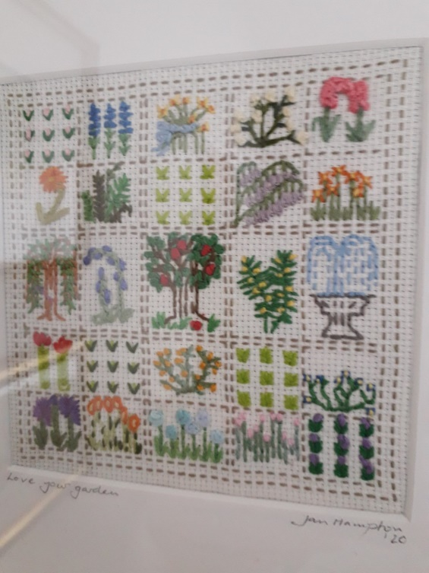

If you would like to contribute to the next RAMBLINGS, please contact Sian on sianrc@hotmail.co.uk or ring on 01606 892157 or
07770863170

Looking to share things you have been up to during the lockdown, any good reads? Films TV programmes you have enjoyed – and of course things you are still looking forward to.
LET’S KEEP IN TOUCH.

Usefull links
facebook – Comberbach WI
Comberbach Community Support

