COMBERBACH WI RAMBLINGS APRIL 2021. Edition 13
Janine’s Jottings – the Great Escape.

I feel as if we are emerging from a long, dark tunnel at long last. We have all been shut away for so long over the last 12 months and I feel as if I need to blink hard as I emerge into the bright light. Winter is never a pleasant time and I feel as if I have been in hibernation but the arrival of Spring is most welcome.

July Meeting
I cannot believe it has been a year since there was a WI meeting in the village, but I am pleased to say that the Hall has been booked for us to resume from the start of July, and what better way to start than with a celebration? The theme of the July meeting is Independence Day and we are going to have a get-together with food, but it will have to be decided if we all bring our own food or do a tasty evening. If the weather is good we will be able to meet in the garden at the side of the Hall and just leave the food indoors, and if wet we shall use the Hall but we can spread out and have doors open. Details will follow soon.

There is also a Marbury Meet-Up planned for Wednesday, May 19th at the covered picnic area from 12pm. We can hope for a good day, or else it may be a case of flasks, rugs and umbrellas!

Sara is also starting the book group again in April, so there are a few things to look forward to and put into otherwise empty diaries! We would like to keep “Ramblings” going until July, when we shall aim for a form of normality ,the newsletter has been well received and has helped to keep our WI members informed. We would love to know what you have been doing since lockdown was lifted. We would like to keep it “fresh” though so we would ask you to consider penning a piece for us.
Cheshire News has made a welcome return and they are being delivered by Committee members.

As far as the “House-Keeping” is concerned, we are soon to lose one of our Committee members and would welcome anyone who would like to join. Shelly stepped back last year as she felt she had other priorities and Mary Evans will not be able to attend very often as she now is not able to drive and is over in Altrincham. Reading through “Ramblings” will reveal who is also about to depart…so that will leave us with 9 on the Committee. We are going to need some help with the booking of speakers. Margery is also relinquishing her role as Vale Royal Group Representative, but Monica has agreed to take the role on later this year. Lindsay and Sian have also offered to help out here.

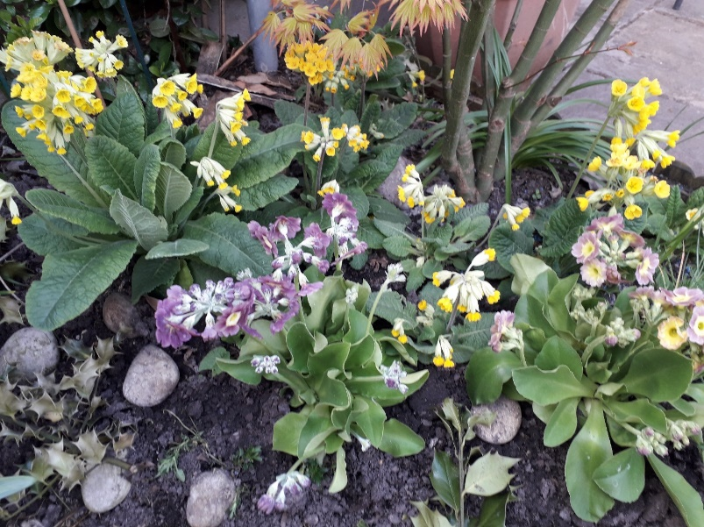
We need to know how our ladies feel about the resumption of trips out. I suspect that booking a coach will not prove popular just yet, but wonder if 2 or 3 in a car to a not-so distant destination would be a goer? I would welcome some feedback on that one. Lindsay is happy to plan some outings, and we might be able to have a garden party. So, let us celebrate the return of our WI! It’s a good excuse to open that bottle of wine…….
Some of my Spring flowers to keep the cheery mood up!

How did Covid change your life? By Lesley Smith.

Have you made any major decisions? Well I have. After 40 happy years in Comberbach I have decided to move near my family. The 5 hour journey south is taking it's toll and I miss seeing my grandchildren. Off I went to see where Laura had moved to. She now lives near Portsmouth in a delightful place with an enormous village green 20 minutes from the sea.

On reading the notice board I spotted the W. I. poster. Laura's new neighbour is a member. "We start our meeting with a glass of wine" she said.

Comberbach has a very special place in my heart and I will miss my friends and my W. I. family. The support I have received during the last few difficult years has been unforgettable.

Of course that means there is a vacancy on the committee so please think about joining. It is great fun to be involved. Keep in touch and very best wishes to you all. My responsibility on the committee is to select and book speakers – If you would like to help with this role in the future – please let a Committee member or Janine know. Lesley

----------------------------------------------------------------------------------------------------------------------------------

A Note from the Treasurer, Rosie
Ladies, can I give a big thank you to all of you who have paid your 2021 subscription either directly into the Bank Account or via a cheque delivered to my door. I have to say, receiving the post has never been so pleasurable, except for on my birthday! So many of you sent with the cheque, a lovely note which lifted the then gloomy days of late March. I think the postman was very curious as to why I was suddenly so popular!
I must also add my deep appreciation to those members who also made a donation to our WI beyond the set fee of £33. The extra funds will give us a bit of a buffer in our finances and I know that we will be able to put the extra money to a use which will benefit all of our members.
So far, I have received subscriptions from 36 ladies, 32 full members and 4 dual members. I am sure you will also be delighted to know that we have a new member, Marion Kirkham, who many of you will already know as she has been an active member of the Comberbach community for many years. We are also welcoming back Penny Cross as a dual member. Hopefully, if the Government’s easing programme continues on track, it won’t be too long before we can welcome them in the flesh.
I also extend an apology to those of you who didn’t receive the letter that we sent out to members in March concerning our subscription rates for 2021. As a committee, we aimed to hand deliver or post out the letter to everyone, in much the same way that we delivered the Christmas Bags but this time our well-oiled machine got a bit of rust. We have managed to speak to those members that we think didn’t receive the letter, but there may be more of you. If so, please contact me on 01606 784858 and I will rectify the situation. Sometimes our strange Covid world gets in the way.
To recap, for those of you who have yet to re-join for 2021, the fee for membership of Comberbach WI for 2021 is £33, although members can donate any sum up to the full fee set by NFWI of £44.
Your subscription can be paid in one of two ways as detailed below:
- By Cheque, payable to Comberbach WI and sent to me at
Cedar Cottage, 16 Leighs Brow, Barnton, CW8 4HT
- By Direct Credit to the Comberbach Bank Account, via Online Banking.
The details for online banking are as follows:
- Account Name: Comberbach WI
- Account No: 73647102
- Sort Code 09-01-56
- Ref: Your name & description (e.g., subs) to enable me to identify you!
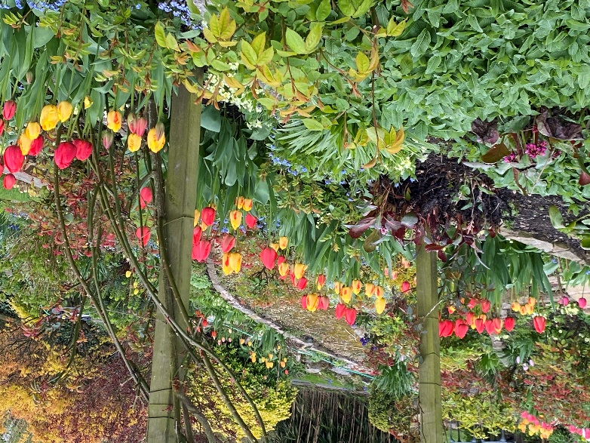
On a completely different subject, I hope that you are all beginning to get out a bit more, if only to admire nature bursting forth. I am sure my plants are growing an inch a day. I attach a picture of some of my tulips which are putting on a magnificent show this year, it makes your heart sing!

_____________________________________________________________________________CCheshire Show – a note from Jean Harding
I do hope you have all enjoyed the Easter weekend and lovely weather. It is so good to know lockdown rules are being eased but we must still take things slowly and keep safe.
As the Royal Cheshire Show has been cancelled again this year, the Trustees felt it would be a good idea to have a Virtual Fun Show which everyone can enter. If you are online your entries can be made via email but there is an entry form if this is not possible. The invitation is attached together with the entry form if a member is not able to submit an online entry.
I realise communication may be a problem but please do the best you can to notify your members of the Fun Show as we feel members will enjoy being a part of this fun event. We look forward to receiving your entries and keep safe Best wishes Jean Federation Chairman

CHESHIRE FEDERATION OF WOMEN’S INSTITUTES VIRTUAL FUN SHOW Would you appreciate an opportunity to have fun when entering a Show where your items are not marked but prizes are awarded? Well, now is your opportunity! The Federation is holding a virtual free FUN show. Prizes will be awarded to the best in each of the six categories with a prize bearing the best accolade of, ‘Star of The Show’, awarded by the Federation Chairman. All category items will reflect something created in the past 12 months. One item per member can be entered in each category but not combined WI entries. Please send separate emails for each class entered, shown on the attached sheet. The final entry date is 30th July 2021 and a video of all the entries and winners will be released on 15th September.
Entry is open on receipt of this invitation. Every competitor is responsible for submitting their own entry/entries Entries must be in photographic form, 6”x 4” (except for Category 5), with your name, WI, email address/phone number and category included and sent to: cfwiwebeditor@outlook.com. Please ask friends or family for help to send online but should this not be possible, post to: Virtual Fun Show, CFWI, 11 White Friars, Cheshire. CH1 1NZ. Please note photographs can only be returned if you enclose a SAE with your entry. Also, if you include anyone in your photographs then do ensure you have their permission for it to be shared on our social media or in Cheshire News. Landscape photographs are preferred so if using your mobile’s camera, please turn it sideways.
CATEGORY 1: OH DEAR! WHAT WENT WRONG A cake that sank; too many holes in the knitting; your wonky artwork; have you made a crosseyed doll; a drooping flower arrangement; a photo with heads missing or back to front and upside down, etc. Please share your funny disasters with us.
CATEGORY 2: HAVE A GO! This is your opportunity to show off your icing and decorating skills. Design and decorate a cake to celebrate a special occasion of your choosing. Send a 6”x 4” photograph, top and side view, of your achievement on a “dummy” cake or ready baked cake.
CATEGORY 3: UPCYCLING Uplifting, Upcycling, Updating. Repair, reuse, remodel and give a new life to something that has seen better days and needs a bit of TLC. Use your imagination!! No limits! Before and after photograph essential.
CATEGORY 4: MY BIGGEST LOCKDOWN ACHIEVEMENT Have you learned a new skill and made a special item as a result. Have you transformed your garden or a section of it, created a new flower bed or taken up art or pottery. Do share your results and send photographs within specification.
CATEGORY 5: A LIMERICK OR PIECE OF PROSE Compose a limerick, or a piece of prose, with ‘Lockdown’ as the theme. Prose compositions should not exceed 100 words. A limerick should have five lines with no overall word limit. Digital entries are much preferred, submitted as a Word document or pdf, and attached to an email in either case. Typed items preferable but clear, handwritten entries will be accepted.
CATEGORY 6: FLOWERS INDOORS OR OUTDOORS Submit an inspiring photograph of your efforts growing flowers during the pandemic. Have you tried and been successful in developing something different or unusual. Did you have an unloved corner of your garden which now sports vibrant blooms or have you grown something indoors which has exceeded your expectations. Do you have colourful displays in pots to share? Submit your successes showing a particular plant/flower you are proud of. We really hope you will enter into the spirit of this FUN show and will let your imagination run riot! The Trustees look forward to receiving lots of brilliant photographs/prose and thank you in advance for taking part!
Jean, Federation Chairman 2021
VIRTUAL FUN SHOW APPLICATION FORM
Please use this form if you are posting in your entry to WI House, 11 White Friars, Chester, CH1 1NZ
For entries emailed in please ensure the information requested below is included in the body of your email. If you are entering more than one category please send them in with separate emails to cfwiwebeditor@outlook.com
Entries welcome at any time but FINAL DATE for entries is the 30th July 2021

Name:

Contact details (if no email)

Your WI:

Please indicate which category you are entering.
Category 1 “Oh dear! What went wrong?”

Category 2 Have a Go!

Category 3 Upcycled – “from this to this” 2 photos
Category 4 My biggest achievement

Category 5 A lockdown Limerick or piece of prose

Category 6 Flowers

---------------------------------------------------------------------------------------------------------------------------------
From Brenda Ives.

I hope the photo of my knitting during the last lockdown will give members a good laugh, they were a bit of a challenge and hope the little boy they were knitted for has fun with them
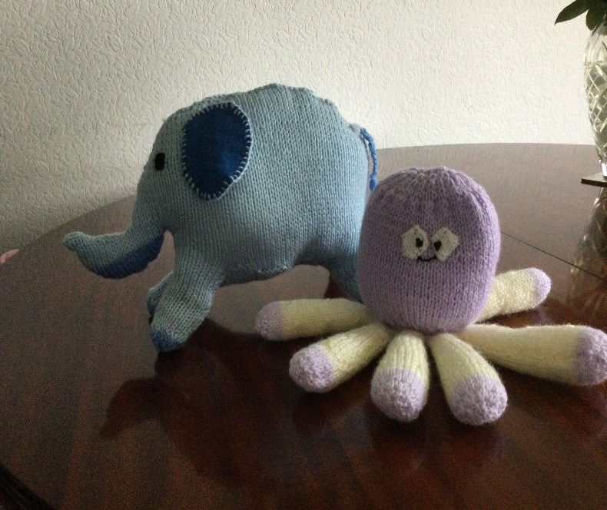
We have started to make plans for our garden so looking forward to better weather and happier times ahead as I am sure everyone is.

I was really spoilt on Mother’s Day with Afternoon Tea delivered to my house from the Hayhurst Arms which I thoroughly enjoyed it was delicious ﻿..
EasterEeggs for Grandchildren will have to be by internet this year, thank goodness for that service and I hope the chocolate doesn’t melt;
Best wishes Brenda

Knitting challenge
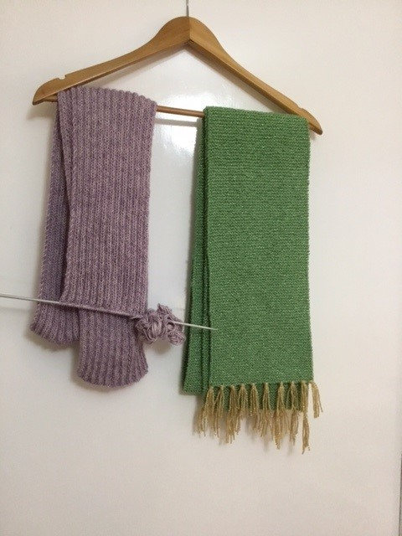
The Scarves project which we talked about in March’s Ramblings has had a great head start with Monica Beech knitting these scarves. We know that a few other members have also got their needles out to help achieve our Knitting Challenge. We only need 3 scarves at 6 foot long to match the height of the Marbury Lady – but it would be good to double or triple this length. We need to nominate a charity/organisation to donate these scarves to at the end of the year – so do please let us know if you have a nomination. The Salvation Army has been suggested so far.

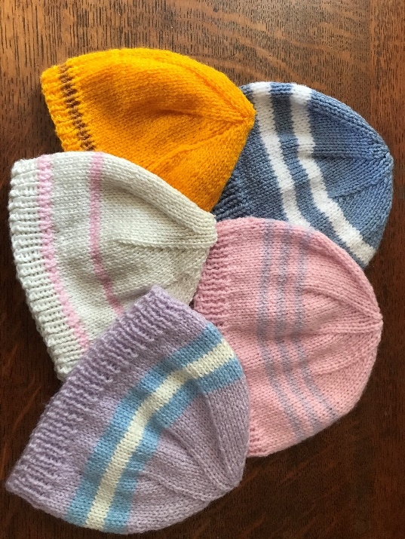

Knitting seems to be the theme for April’s edition! Members have been busy knotting Hats for Special Care babies – These are my efforts so far (Sian)

It seemed I went a bit crazy during Lockdown and convalescence knitting these little characters. It has been quite amusing – and I hope my Grandson will enjoy them for years to come! All 22 of them! Sian xx
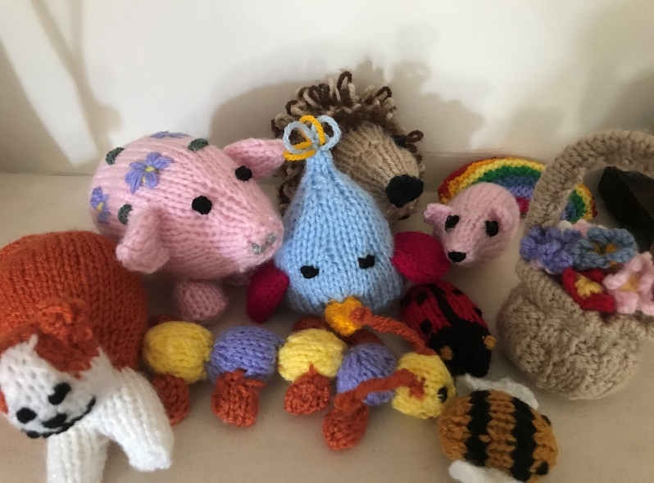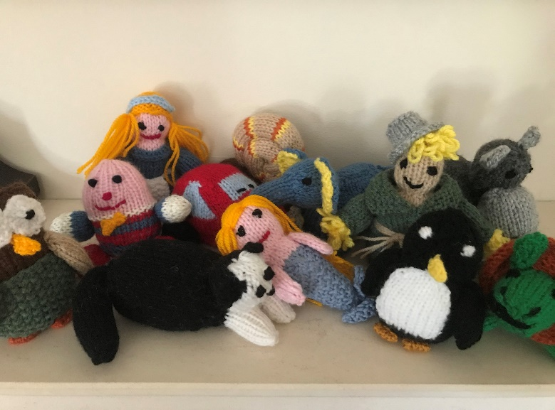

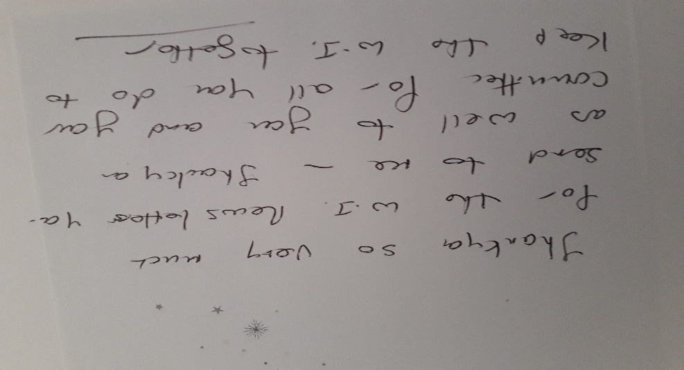
Thank you’s–
Janine and Rosie have received quite a few thank you greetings and cards over the last few month. This was a lovely one from Joyce Stock…
We do appreciate hearing from you…

______________________________________________________________________________
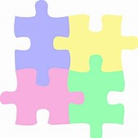
The jig-saw swap has mustered quite a bit of interest – and it’s something we could do towards the autumn and winter months once again – as now with the better weather and lighter evenings, the appeal is not as great. Thank you to all who have swopped!

Beautiful Jewellery created by Wendy Green.

This is a photo of Wendy’s latest creation.

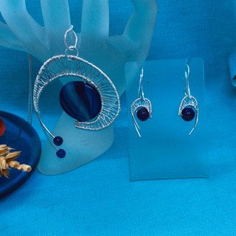
Wendy says -
Lockdown has empowered me to hone my skills in wire weaving and I am very proud to be able to do work of this quality.

I had inspiration from two sources and this is the result of both my design skills and my ability to work with wire.

My sight loss hit me so badly because 8 months into treatment I woke one morning to dense blackness in one eye.

That is why I faltered in starting the workshop. I wasn’t really ready at all to do that.

God bless you all, Wendy
_____________________________________________________________________________

Please submit any articles, stories, tales, recipes and photos to sianrc@hotmail.co.uk by 10th May.
Best regards to you all. Sian and the WI Committee.

