

COMBERBACH WI RAMBLINGS. March 2021. Edition 12

Janine’s Jottings

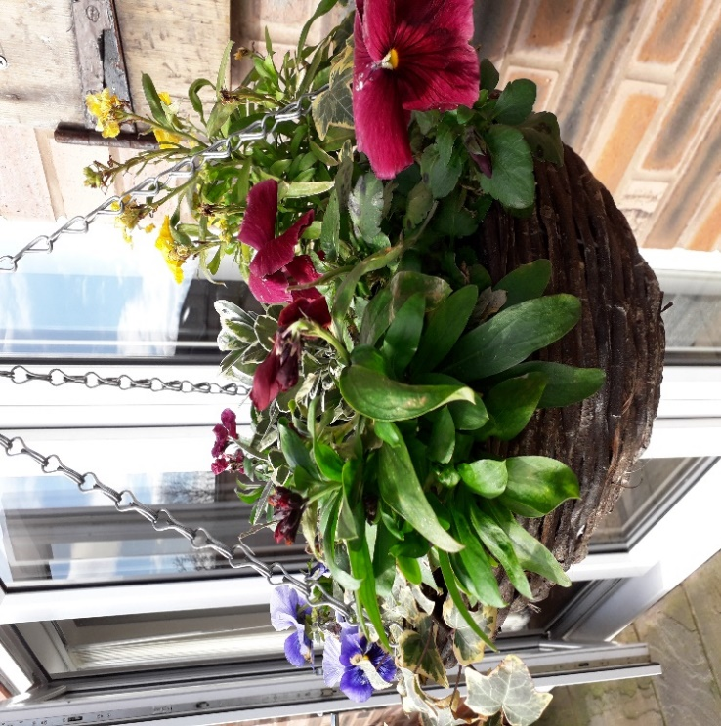What a difference a couple of months make, and some much-needed sunshine too! The remaining winter months have now disappeared into a distant haze and I am glad to say that we have seen the back of January and February. I find these two months rather depressing. It is the big let-down after Christmas, cold, wet and still dark at the times when I would prefer it to be light. It certainly lived up to the cold, wet and dark, but at least we were spared flooding, despite the town being affected. It is always difficult to remain positive, especially with all the restrictions we have to abide by, but the sight of the bulbs in my garden pushing up through the soil and a few brave daffodils in bloom, remind me that Spring is just about here, and with it, the other Spring flowers, blossom and lighter evenings to enjoy them all outside.

Many of our WI members have shared photographs of the crocus pots we distributed at Christmas and the pots have given much pleasure. I have now planted my crocus, and they have started flowering again! The mild spell and the sunshine have enabled me to tidy the garden and rescue a couple of plants which had been affected by the adverse weather. I also filled 3 large bags with fallen leaves at the front. A week on, and my bulbs are well up now - tete a tete daffodils and ordinary daffodils are starting to flower. My hyacinths have struggled but are in bud although the leaves have been nibbled. I might be able to smell them this year. I also have Fritillaria and grape hyacinth in both blue and white making progress but the dwarf tulips appear to have perished or have been dug up and eaten. There are quite a few birds around too, especially since my lovely tabby cat passed on – he was an absolute terror for chasing them. My winter hanging baskets have survived well as you can see …

I would think that all our WI members will have had their first Covid vaccination by now and some ladies have even had their second dose. It shouldn’t be long before we have all had our second vaccination and it will hopefully give everyone more confidence to go out and about again, although I think some of our ladies may be remain little cautious for a while. We are not out of the woods yet but we are encouraged by the reports we keep getting and we hope to get some activities up and running before too long.

When we get back to groups of six outdoors again, we should be able to re-start the walking group and have some outdoor get togethers – with flasks and blankets in Marbury perhaps? By summer, we may even be able to hold a garden party. We have a few ideas for that one.

Restrictions are set to end by the start of July, providing there is no spike in infections, so the Committee has decided to start booking the Hall for a few activities and we hope to kick off the re-start with a general get-together/party - with some food, so everyone will be able to sit, chat and catch up – possibly in July or August. Depending on take-up, we can then organize a programme of sorts up to Christmas. Rosie is organising the Hall side of things.

**Cheshire Show**

It was hoped that the Cheshire Show would be able to go ahead this summer, but even if it does, it has been decided by Cheshire Federation that the WI will not have a presence at Tabley. The WI has always had a huge marquee at the show, but not this time. The Federation decided it would be unwise to risk the health of its members and their families, which is sensible, but we will all rue the loss of the show this year.

With that news, I used the jar of apricot jam which I had made especially for the show as no-one will want to judge a two-year old jar of jam next year. It has a good flavour and the lid came off the obligatory “pop”. We shall have to look ahead to the summer of 2022. It does give us all a good yardstick for re-starting our own WI – not to do too much too soon. For all Show afficionados there might just be a Virtual Show, where WI members can showcase what they have been making. We shall wait for news on that one. Margery will have to put her Cheshire Show meetings on hold for a little longer……

**Vale Royal Group Representative.**

After many years of excellent representation, Margery has decided the time has come to step down from her role of Vale Royal Group Representative.

We have had a couple of firm offers from Committee members to take over the role, but Margery says it does not need to be a Committee member who takes this on. If you are interested, please let me know very soon. My number is 07756 854042. It may also be possible for 2 people to work together on this one, especially where Group activities are concerned. It is always useful to have a back-up for when meetings cannot be attended. If I don’t hear anything, I shall go ahead and allow one or both Committee members interested to do the job. I want to take the burden off Margery’s shoulders fairly soon.

Stay safe everyone – we are getting there…it’s a marathon, not a sprint!

Janine.

_____________________________________________________________________________

**Update from your secretary.**

I have been thinking what has happened since the last edition of Ramblings and I hear you saying, not a lot. I think we are all feeling weary with this latest lockdown. It feels never ending. A lot of us have had a cancelled Christmas and all the cold dreary winter weather has not helped but I often see WI members getting out in all weathers for their daily walk. Onwards and upwards.

Now dear Boris has set a timetable for getting out of lockdown we are all keeping our fingers crossed and making plans. I am hoping to book a self-catering establishment in the North East for a couple of days after April 12th so as to see relatives and friends albeit in an outdoor venue. I hope some of you are planning to meet up in each other’s gardens after the 29th. The libraries are due to open on the 12th April so I am hoping to get some new books for the book club and hold our first meeting in my garden on the 20th April.

I am sure Janine will have mentioned in her report the tentative plans we have been discussing for starting up WI meetings again providing the government timetable remains unchanged.

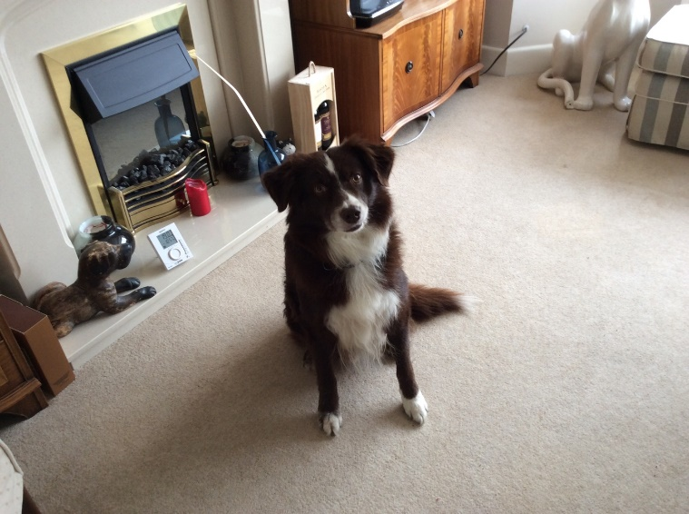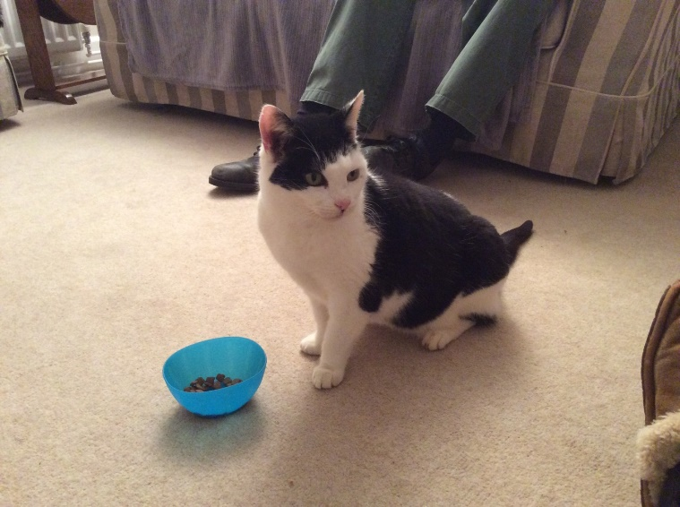I have been very good and trying to take a long walk everyday which requires a lot if discipline since I lost my old dog last November. The house has also been a little empty with no grandchildren or pets so I adopted a cat from the cat rescue and then managed to find an older dog to re home. Some of you may have seen me round the village with a brown and white collie. He is called Sammy the same as Lindsay’s dog. It is a bit of a risk adopting an older dog as the saying goes,” you cannot teach an old dog new tricks.” I have been lucky as he walks well on the lead and is very well behaved. His former owner was an elderly lady who walked with a stick and was losing her eyesight so she could no longer safely walk Sammy. I keep in touch with her and when lockdown eases, I may take him back to see her as she lives in Wales and I would not be allowed in at the moment. Her grandson brought him over as he was a carer and allowed to travel plus had been vaccinated.

I have now decided that as I was not particularly good at growing vegetables last year that I will plant flowers and herbs in the patch instead so a trip to the garden centre is imminent. It is a shame it has started raining and will be wet for quite a few days as it will be too muddy to plant anything. I may have to leave it a little longer. The green bin is being collected again so that means I had better get some clearing up done!

I hope some of you manage to get together soon. Sara xx

**Janine’s Simnel Cake for Easter. (This is a “Good Food” recipe)**

**Ingredients**

* 250g mixed dried fruit (a mixture of sultanas, currants, raisins and candied mixed peel) but you may want to use more…
* 1 [orange](https://www.bbcgoodfood.com/glossary/orange-glossary) , zested and juiced
* 500g pack [marzipan](https://www.bbcgoodfood.com/glossary/marzipan-glossary)
* 250g pack [butter](https://www.bbcgoodfood.com/glossary/butter-glossary) , softened
* 200g [light brown soft sugar](https://www.bbcgoodfood.com/glossary/sugar-glossary)
* 4 [eggs](https://www.bbcgoodfood.com/glossary/egg-glossary) , plus 1 beaten to glaze
* 175g [plain flour](https://www.bbcgoodfood.com/glossary/flour-glossary)
* 100g [ground almonds](https://www.bbcgoodfood.com/glossary/almond-glossary)
* 1 tsp [baking powder](https://www.bbcgoodfood.com/glossary/baking-powder-glossary)
* 1 [lemon](https://www.bbcgoodfood.com/glossary/lemon-glossary) , zested
* 2 tsp mixed spice
* 1 tsp [vanilla extract](https://www.bbcgoodfood.com/glossary/vanilla-glossary)
* 100g glacé cherries , halved
* 3 tbsp apricot jam

**Method**

* Put the mixed dried fruit in a [bowl](https://www.bbcgoodfood.com/content/top-five-mixing-bowls) with the orange juice and zest and 2 tbsp water.
* Cover and [microwave](https://www.bbcgoodfood.com/review/best-microwaves-test) for 2 mins, then leave to cool completely. Alternatively, heat gently in a pan, stirring now and then until the liquid has been absorbed and leave to cool.
* Heat oven to 150C/130 fan or gas mark 2.
* Roll out a third of the marzipan and use base of a 20cm cake tin to cut a circle.
* Keep the offcuts with the remainder of the marzipan.
* Grease and line the cake tin well – 20cm tin
* Beat butter & sugar together until creamy
* Add eggs, flour, almonds, baking powder, lemon zest, mixed spice and vanilla – all in one go – and mix until well combined
* Mix in the cooled soaked dried fruit and fold in the cherries.
* Put half mixture into tin.
* Top with disc of marzipan
* Add remaining cake mixture and level off
* Bake approx. 2 hours
* Check with skewer – it should come out clean.
* Leave tin to cool, then turn out and cool completely.
* Brush top with apricot jam
* Roll out remaining marzipan to top the cake and place carefully. Crimp the edges.
* Use remaining marzipan to form 11 balls and place at equal intervals around cake.
* Brush with a small amount of beaten egg to aid colouring
* Place under hot grill for a couple of minutes but be careful not to burn the marzipan!
* Add ribbon around the cake. You may also wish to decorate with flowers.Bottom of Form

[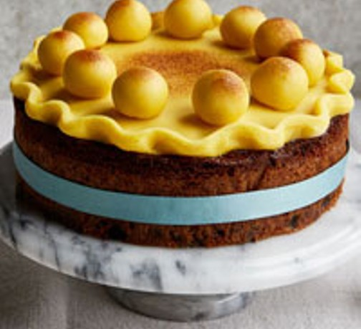](https://www.bbcgoodfood.com/howto/guide/top-10-easter-cake-recipes)

Knitting Challenge – The Crafty Lockdown Challenge.

You may recall that we featured the scarf knitting challenge in last months Ramblings. We have now identified the Marbury Lady as the target length to knit to!

The sculpture is inspired by a ghost story associated with the former Marbury Estate. People in the area frequently claim to have seen this ghost as she haunts the park. The most recent sighting is reported as being last year!

This feature was carved by Simon O’Rourke. Simon has carved many figures from [books](https://www.treecarving.co.uk/radagast-the-brown-blue-and-pink/), [movies](https://www.treecarving.co.uk/case-studies/batman/),  [myths and legends](https://www.treecarving.co.uk/a-phoenix-arises/), but he thinks this is the first time he has carved a ghost!

The first challenge for us was to measure the height of The Lady. Richard and I set off with a good old fashioned tape measure and a laser beam measurer. Needless to say the modern technology won the day – and the carving comes in at a height of approximately 16 feet.

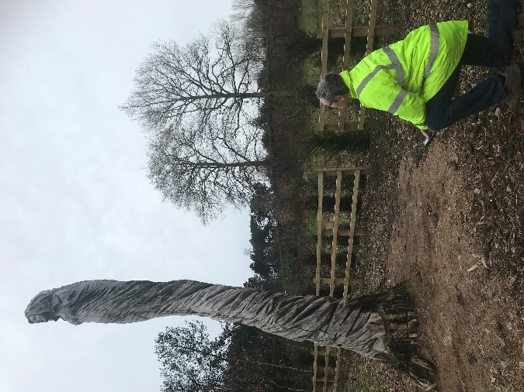

So we only need to have 3 x 6 foot scarves to complete this target – however it would be great if we could double or triplicate this length in scarves.

Monica has already accepted the challenge and is happy get knitting – so any other contributions will be gladly received – so please let Monica know if you are interested.

Modern equipment saves the day!

**New Baby/Premature Baby Hat.**

Monica has been keeping herself busy knitting hats for Special Care baby units. This is such a worthwhile cause – so we include the knitting pattern in case you are interested in contributing to this project.

**New Baby/Premature Baby Hat.**

4 ply and 3.25mm needles.

Cast on 88 stitches

K1, P1 – Rib for 8 rows.

Stocking stitch until work measures 9 cm.

Decrease –

(K row) (K9. K2 tog) to end of row.

(P Row) – purl to end

(K8. K2 tog) to end

Purl

(K7. K2 tog) to end

Purl

(K6. K2 tog) to end

Purl

Continue to decrease as above till 8 sts remaining. Thread the 8 stitches onto yarn and pull tight. Sew side seams.

____________________________________________________________________________

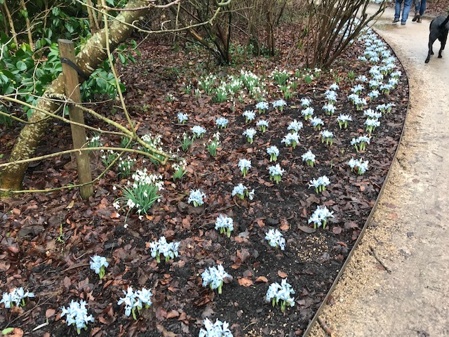Lindsey recently visited **Dunham Massey** and took a few pretty photos.

She reports that they allow dogs. Please note that they have reduced the admission times – so please check before you go – Also snacks are available.

**Sian** visited **Arley Hall Gardens** last week, which like Dunham Massey was a carpet of snowdrops. The Daffodils, Azaleas and Rhododendrons are on the verge of blooming – so I guess in another few weeks and it will be well worth another visit. Arley Gardens also allow dogs on leads and the Stable Café is open with a reduced menu. The Garden Centre is also now open.

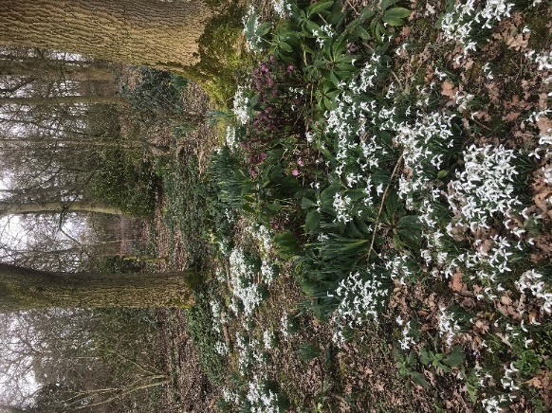Walking round the gardens and the village lanes are all helping towards my recovery after my Hip operation. – I am managing to walk between 2-3 miles a day quiet easily. Although I am frustrated that I can’t bend down to tend to the garden for another few weeks, or go on my bike – I must be patient – and not risk anything going wrong at this stage!! Happy easter everyone – and let’s hope we can all meet up before too long.

**Jig Saws** - I have exhausted my supply of jig-saws- would anyone be interested in doing a swop? I am sure there must be a few fellow jig sawists in the membership who would like some fresh challenges. I am happy to coordinate! Sian xx

*Next edition*

Please submit any articles, photos etc to Sian at [sianrc@hotmail.co.uk](mailto:sianrc@hotmail.co.uk) by the 10th April.