

COMBERBACH WI RAMBLINGS November 2020 8th Edition

Including Officers Annual Reports.

Presidential Ponderings. November is here again, and I can truly say that the status quo has been maintained, in that nothing of note has happened, with the exception that your President has had a milestone birthday last month and for the record, I am going to stay 69. “Ha!” I hear you say” - a mere youngster” and “you won’t be catching me up yet!” All I can add is “Thank goodness that one is over!” I can’t believe how quickly this year has gone, despite having to spend much of it at home.

Lest we forget, November is also the month of the AGM. Having emailed Jean Harding, I was assured that we could dispense with the formalities, provided that all our Officers are willing to continue. You will be pleased to note that we are all staying firmly put, so the prospect of twisting arms up backs to help us out has been avoided. We have been asked by CFWI to provide Officers’ Reports for all our WI members to peruse, so you will find these included in this issue. These reports were circulated to all Committee members prior to October’s Zoom Committee meeting and have been formally proposed and seconded by Committee members, and everything has been minuted. You are all welcome to make any observations.

The Committee was also delighted to welcome Margery back online, but since our meetings are limited to 45 minutes, so we don’t have to pay to use the facility, we had to get the business done, only leaving us a short time to chat and welcome her back. Margery did say that she is also trying to get back to online Vale Royal Group meetings, as well as resuming contact with the Agricultural Society. Her progress continues, we are so pleased to note!

Sadly, as indicated earlier, we have to report that nothing has taken place on a formal basis, and no-one in their right minds would want to meet up in Marbury, given the amount of rain we have been having. I need to dig the wellies out. I can’t even spend much time outside to tidy up and I have now decided that the wettest part of my limited outdoor space would make an ideal bog garden. The slugs, however, are sharpening their teeth and having a field day, chomping on what is left. I have put some gravel down and I hear that beer is good too, but don’t fancy disposing of the bodies afterwards! My planted bowls have been put on the patio table out of their reach!

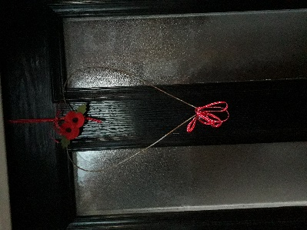Next month we are going to discuss activities which we can provisionally book for next year, as this pandemic can’t go on for ever…we hope! We just hope that this latest lockdown has the desired effect. We are looking to arrange an outing for the summer, as well as re-booking some of the speakers we had hoped to have this year. We shall also look at the possibilities of rearranging a meal so we hope to be able to “hit the ground running” once we eventually get the all-clear. We are happy to listen to any suggestions and wishes our members may have. We all need something to look forward to and my next door neighbour has reminded me that December 25th is not that far away by hanging a Christmas wreath on her front door before we had even had Halloween or Bonfire Night! Whether we will be able to celebrate with all family members is another matter, but we live in hope and I hope no-one will be on their own. Moving on………stay safe! Janine Hampton.

Not to be beaten - Janine’s answer to next door wreath!

**Comberbach WI Annual General Meeting Reports for 2019-2020**

**President’s annual report – November 2020 for record in lieu of AGM.**

No-one could have foreseen what this year had in store for us all when I was chosen as President in November 2019, and what effect the Covid pandemic would have on our WI. As a result, our AGM is not going to be held this year, but having established that our key officers are willing to continue in their posts, Jean Harding has advised me that we are not obliged to hold an official AGM. We are, however, obliged to produce the usual reports from myself, as President, from Sara, our Secretary, and from Rosie, our Treasurer, and these will serve as “minutes”. We sincerely hope that next year will be different!

For me, the year got off to a good enough start. I consider myself fortunate to have the services and support of an excellent Committee, and we number 12 in all, a good number, which gives us cover in the event of illness, problems etc. Little did we know how much this “cover” would be needed. It has been a difficult year in so many ways, with various illnesses taking their toll, as well as Covid effectively cancelling the rest of the year after we had held our March meeting. We have missed out on so much as a result: our monthly meetings, Vale Royal Group meetings, darts, the Birthday Party, a planned theatre trip, a fish and chips cruise, a trip to the Ulverston area, and now, our Christmas meal. The Cheshire Show has also been a casualty, sadly, but we have to remain optimistic, anticipating its return in 2021.

Communication has been key. We have managed to hold Committee meetings on Zoom. We have also managed to get the sub-groups going again in a limited way, but meeting in gardens and parks is less than ideal at this time of year, but we have had some success. Regarding communication with our WI members, our “Ramblings” newsletter was launched, phone calls and emails have been exchanged and we have set up a “Send to All” message scheme, so everyone can be informed about what is happening. CFWI has organised a good selection of Speakers to address WI members on Zoom, and these have been excellent. It is a shame that not all of our WI members can access it. We are becoming more limited as to what we can offer our members in terms of meeting up, but we shall continue to keep in touch. We are hoping to launch a members’ meeting on Zoom soon, for those who are happy to use the technology. In the meantime, we can only hope that restrictions will be eased in the New Year, and that we will be able to return to the Hall.

In the midst of all this upheaval, I must not forget the efforts of the Committee, all of whom I must thank for their contributions and efforts, however small. Rosie has worked wonders again, making sure that the books remain balanced, Sara has continued to deal with our correspondence and produce minutes for our Zoomed meetings, Irene and Monica have looked after raffles and prizes, Lesley and Shelly have dealt with the programme, sadly, having to cancel, rather than book, Lindsay has been very proactive in organising outings for us, and again, having to cancel them, and Sian has done a sterling job in keeping the lines of communication open, as well as keeping the website updated. I mustn’t forget all our other Helpers, who do their fair share in helping to keep the Comberbach WI cogs well oiled, especially Cynthia, who has kept me informed about who has been unwell, and I thank her for sending cards out as needed.

So, let’s get Christmas over with and we shall raise a virtual glass to each other, and look forward to the Spring, the reduction in the Covid infection rate, the easing of restrictions and us all being able to meet again.

I offer up this report as a true statement of the past year for Comberbach WI. Janine Hampton President.

*Proposed by Sara Smith, Seconded by Rosie Rowe*

**Treasurer annual report – November 2020 for record, in lieu of AGM**

I am pleased to present to you my third Annual Report as Treasurer, but as I am sure you will understand it is quite different to my previous reports.

Our Financial Year runs from 1st October to 30th September each year, so at the beginning of October I produced the annual financial statement, which was duly handed to our auditor, Mr Steve Penwill for his scrutiny and final approval. As of writing this I am awaiting the results of his audit.

Under normal circumstances I would provide copies of the last bank statement and a copy of the accounts for members to study at our AGM. This is not taking place so instead I will be happy to discuss the accounts with any interested members by phone.

As noted, this Financial Year has been far from normal with almost all of our activities being curtailed in March. From that point we have had no income but some modest outgoings such as payment for the Memorial Hall to March, maintenance of our website and minor Members’ expenses.

The following are the main points I wish to make you all aware of:

* Our final Bank Balance for the year is £3820.53 which is only £30.74 down from last year.
* The two events we ran prior to lockdown, i.e. the great shopping evening to John Lewis last November and the Christmas Meal in December were effectively cost neutral.
* Our speakers’ charges were within our budget as were other expected charges such as hall fees.
* We gained £67.50 from the Christmas Raffle and from closing the Trading Table,
* Ten members benefited from a half day felting course which was paid for out of the Bursary awarded to Janine Hampton. Thank you to Janine for offering part of her Bursary for this activity.

As in other years, we have benefited from some excellent speakers and demonstrators at our meetings, (at least up to March), free refreshments at meetings and free copies of the CFWI Cheshire News. We also benefit from having our own website and Facebook page and of late a monthly Newsletter of our own, “WI Ramblings”.

Our current membership stands at 60 which includes 4 dual members. We welcomed one new member this year. As you will all be aware the subscription fees for 2021 have been delayed until 1st April and will be due on that date hence forth.

As noted, most of our activities have been curtailed and it could be many months yet before it is possible to have face to face meetings back in the Memorial Hall. Many of our ambitions have had to be put on hold but the one thing we are absolutely committed to is keeping everyone engaged and hopefully eager to return to the WI meetings when the world gains some normality.

Finally, I hope this report meets with your approval. Overall, our accounts are stable and in a healthy condition considering the current circumstances. It has been my honour and privilege to serve as your Treasurer over the last year and I look forward to the next year with hope.

I propose the adoption of the Financial Statement.

Rosie Rowe Treasurer

*Proposed by Janine Hampton, seconded by Sian Chandler*

**Secretary annual report – November 2020 for record, in lieu of AGM**

This has been a rather unusual year for our WI. It cannot be said to be a good year but it has had it’s moments. We have sadly lost Betty Moore a long standing loyal member when she died in January. We were also shocked to hear that our Committee member extraordinaire, Margery suffered a serious illness but happily is now making good progress and she hopes to be back to take part in the Cheshire Show of 2021.

I became secretary after last years AGM unopposed. I felt I had enjoyed 2 years of friendly committee meetings with plenty of tea and cake as a simple committee member and that now I should be willing to do a bit more especially as most of the committee has already done their stint as one of the officers. I took the job on knowing that I had plenty of people with experience to help me.

It would appear that it is my duty to report back on the activities of the committee. They have all worked very hard particularly in the unusual circumstances we now find ourselves in.

Our programme for this year was all planned and set out for everyone to enjoy and it has been with much sadness that since March they have had to cancel one speaker after another when it became obvious we could not continue not to mention the exciting trips that were being organised that would have to be cancelled. We are hoping that many of the cancelled speakers can be rebooked and trips reorganised.

Lindsay Entwistle retired as our president but volunteered to help as a simple committee member as she had a lot of good ideas and contacts to arrange some very interesting outings.

Before the sky fell in we managed to enjoy a lovely Christmas meal. We also had an enjoyable evening with a Beetle drive although there was a little bit of a dispute re the rules.

We managed to enjoy a lunch at the Antrobus Arms in February and there were plans to arrange another one. We took part in one of the heats for the County Quiz and although we did not qualify for the final we were looking forward to hosting the final in the April. A number of members enjoyed the pom pom felting course and produced some lovely fluffy dogs. We were about to take part in the Darts competition which was cancelled at the last minute along with the group AGM.

The committee were putting in a lot of work organising our 70th Birthday Party. Jean Harding was invited and had accepted. They had planned a party based on the WI through the ages, had arranged for a deluxe cold buffet and were working on some interesting exhibits and games.

Cheshire show meetings commenced with a lot of inspiring ideas being put forward for our entries. A Fish and Chips canal cruise had been arranged plus a visit to a Buddhist Temple in Ulverston. Lindsay was also trying to arrange a theatre visit to watch The Mousetrap.

Alas as lockdown was looming it became obvious that these activities would not be able to take place and the committee had to start cancelling everything.

To start with we felt some events may still have been able to take place or be delayed for a while. It soon became obvious that that was not going to happen. We even hung on until about a month ago before cancelling this years Christmas Party.

In the meantime, the committee started writing and circulating Ramblings which has been a great success with many thanks to Sian for all her hard work assembling everyone’s contributions and circulating it. It has then become a monthly publication which is much appreciated by everyone.

Committee meetings moved to Zoom thanks to Janine who sorted it out with the help of her son and despite Covid rules preventing Leslie from having her usual garden party we managed an outdoor get together in Marbury Park in the summer.

A lot of us joined in with the front garden Comberbach Fete and friends have spent summer meeting in their gardens. The book group has managed a few outdoor meetings of 6 and the walking group have so far managed a get together in Ursula’s garden and a ramble round Marbury.

The committee have looked into and discussed at length restarting meetings but decided it was too complicated at the moment. They have also formed a Buddy system so that members can be consulted for their views on joining any zoom meetings or activities.

I would like at this point to thank all the committee members for all the hard work they have put in this year arranging and cancelling speakers and events and also coming up with innovative suggestions to keep all members in touch with each other and being available to assist if asked.

We are now approaching AGM time again and the committee debated whether to hold it on zoom but felt there were too many members who either did not have access to a computer or did not feel confident enough to join a meeting. We have been told by County that in the circumstances if all the officers and committee members are willing to continue we can minute the details and no formal AGM need take place. My report together with the President’s and Treasurer’s are therefore to be published in Ramblings for everyone to read if they wish.

I am happy to continue as your secretary and look forward to when I can minute a member meeting again. Sara Smith, Secretary.

*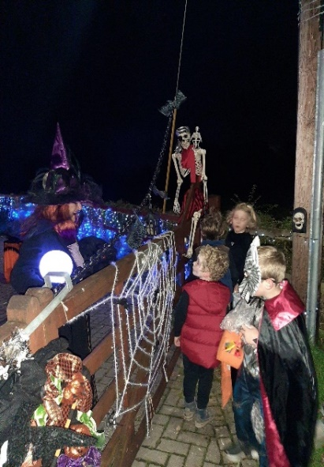Proposed by Janine Hampton, seconded by Lindsey Entwistle.*

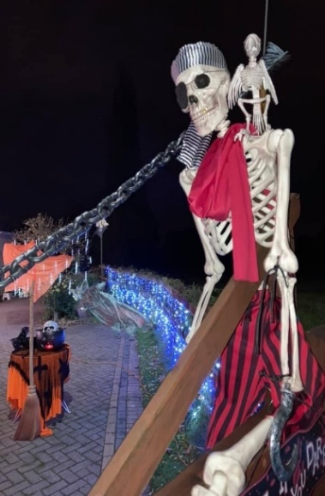Halloween by Elaine Perry

Comberbach exhibited it’s community spirit once again with the ‘Light up Comberbach’ event for Halloween in glorious technicolour.

There were ghosts, ghouls and spider webs galore, people still finding an appropriate way in these strange times to give a little entertainment and a sweet treat or two for the children to collect.

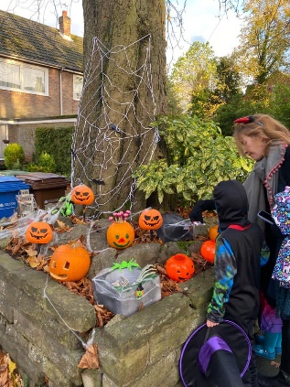I’m afraid my house was in darkness as I was at my daughters for the weekend, joining my family bubble and viewing their locally dressed houses with my grandchildren, Sophie aged 3 as a witch and Ollie 5 as a skeleton. The decorations were amazing, it was obvious to see that people were in need of some light relief as lockdown loomed once again and made the most of rising to American standards of marking Halloween. I remember being in New York in 1997 witnessing their October 31st celebrations which I found amazing, it was much more low key in the UK then. A few years later staying near San Francisco with friends I knew what to expect. The city workers, business people etc dressed quite outrageously going about their business and the houses were very elaborately dressed.

Many people in the village are leaving up their outdoor lights in preparation for Christmas. I suspect Comberbach may be even brighter and more colourful this year, hopefully in celebration of an easing of lockdown as well as marking Christmas itself.

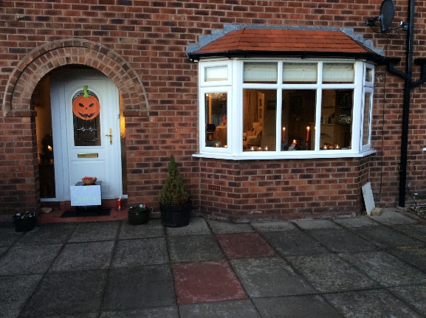**Sara’s contribution to the Halloween and lights event in Comberbach.** A lot of families with children seem to have toured the village looking at all the decorations and picking sweets off bushes and washing lines. My sweets were in a basket outside the front door and instead of the usual knock at the door I heard the chortle of delight when the children found the sweets and a little boy who was dressed up peering through the window. It was charming. Everyone in the village seems to think it was much better than the usual Halloween.

I also had a bonfire night celebration in my garden on the 4th(brought forward a day) I lit my fire and we had sausages baked potatoes and parkin. The neighbours set off fireworks which we watched. Just the 5 of us but it was a lovely evening. I will now have to find more stay at home things to do for the next month, I could even start my Christmas cards early, I am usually always late sending them off. This lockdown will hardly bother us unless we need our hair doing. We will just have to be a bit more organised with our Christmas Shopping. December may be a bit busy!  
Don’t forget if you need anything even if it is just a chat ring your Buddy group leader. That way no one should feel on their own.  Sara”

_____________________________________________________________________________

**WI online, CFWI Zoom Talk review by Margaret Jefferson.**

For some reason, I missed the first of the Zoom talks titled” Inspirational Women” offered by Cheshire Federation.  Maybe it clashed with Bake Off!

I decided I ought to take advantage of the opportunity to hear what was offered. After all it is available to all Cheshire members. The second talk was billed as an account of the speaker’s early onset dementia. The subject did not sound particularly appealing, but my misapprehension was quickly dispelled.

Fulshaw Park WI reading group had read Wendy Mitchell’s book “Somebody I Used to Know”. The book proved popular, so when the board of trustees were considering speakers for the upcoming Zoom talks it was suggested that Wendy be invited.

She worked as a busy and dedicated administrator in the NHS, organising rotas for teams of nursing staff. Diagnosed in 2014 with “Early Onset Dementia” at the age offered v58, life changed radically for Wendy. Early retirement followed some months later.

Technology features large in Wendy’s life now. Reminders of mealtimes, and engagements, writing a blog. She continues to live alone, with support from her daughters.

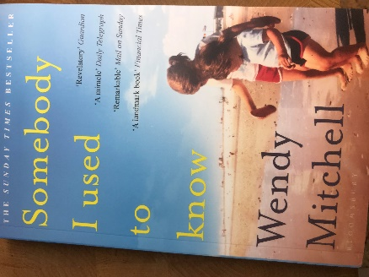Despite all life’s limitations, she became involved in a dementia support group in her home city of York.

Now she is an ambassador for Dementia Research, working to raise awareness of the disorder, speaking to professionals and lay workers.

Wendy was an engaging and inspirational speaker. I am now enjoying her book, written in collaboration with Anna Wharton. – “Somebody I used to know “

*I also ordered a copy of the book which I have now read, I am very happy to pass it round. Let me know if you would like to borrow it in due course. Sian x*

Denman on line Courses.

Sian recently joined around 90 members on the Cryptic Crossword taster session run via Denman – it was fascinating, but the Cryptic world still is mysterious to me! - Have a look at this link to see if anything floats your boat….. <https://www.denman.org.uk/whats-on/>

--------------------------------------------------------------------------------------------------------------------------------

* Greetings from Hampshire. I am yet again playing the part of Lock down Granny. Guess what, the children have grown so pushing the double buggy is now a really good workout. Unfortunately, the sleeping habits are the same. It's musical beds most nights. Felix, now 9 months is a charmer and loves bashing his toys. He has very healthy lungs which is a mixed blessing at 4 in the morning. Sarah is Sarah with a lovely smile but lots of hard work. Lifting her is getting more difficult with her long legs. Great excitement here as they are moving house shortly and have actually signed the contract. There is a downstairs bedroom for Sarah and lots of space. The new house is close to Portsmouth. I am looking forward to a paddle in the sea when we are allowed. Let us hope things return to normal soon and I look forward to seeing you all before too long. Very best wishes from Lesley.
* As you can imagine there has been no walking or even meeting up with the Ramblers recently. We did think that we might have managed a local one in September but it rained!   
  On behalf of the Ramblers we wish all our friends in the W.I. A very happy Christmas and New Year and we look forward to seeing you all next year. Ursula

--------------------------------------------------------------------------------------------------------------------------------November’s not that bad! By Rosie Rowe.

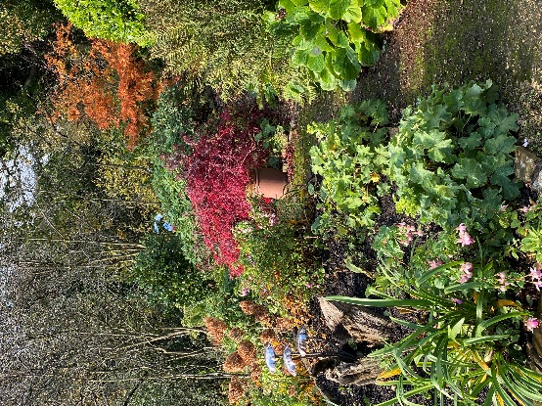November can seem a dreary month. The dark nights are with us, the mist and damp and fog and on the rare occasions we see the sun, it is mellow and weak. Put another take on it as far as the garden goes and there is still much to gladden the heart. Grasses back lit by sun, berries on the trees and blankets of golden and red leaves from the acers carpeting the ground, all give delight.

This year we have so far escaped the frosts so in my garden, I still have a profusion of flowers which I am able to cut for the house. Annual cone flowers, late flowering delphiniums, deep red persicaria, delicate fuchsias and the stalwart Dahlias all give splashes of colour and although the colours are not as vibrant as at the height of summer they have a different but no less appreciated charm.

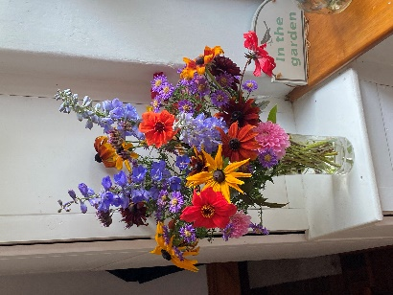A walk around the garden or just around the hedgerows can reveal hidden gems under the blanket of fallen leaves. If you look carefully there are already signs of growth in next years spring bulbs, a reminder of all that goes on unseen in the ground.

Half an hour in the garden at dusk is magical at this time of year. We have at least two types of owls and they call to each other from late afternoon. The blackbirds, robins, finches and wrens are in full voice and then, just at night falls, the bats sweep over the garden and the hedges. Who cannot feel joy at such natural delights?

When all else fails, you can plan. If you are mad keen like me, burning questions are what vegetables shall I grow, where am I going to plant all the tulip bulbs that now need to go in the ground, what annual flowers will I grow to plug the gaps in high summer, what changes will I make in the lay out of the garden next year (all gardens evolve and often faster than you expect), the list goes on. As you will gather, I love my garden. It brings me peace, joy, and a feeling of well-being much needed now. As many gardeners say, November is not the end but the beginning of the next gardening year and I fully concur. Here is to a splendid 2021! ________________________________________________________________________

Recipe…by Janine Hampton

A straightforward recipe for Macarons - as featured in the Great British Bake Off These little treats are relatively easy to make and are great for a festive buffet. Why pay M & S prices?

1. Set oven to 160 degrees C
2. Mix 125g ground almonds and 200g icing sugar together – set this aside.
3. Whip 3 egg whites in a large bowl to stiff peaks.
4. Slowly whisk in ½ teasp. cream of tartar and 2 tbspns. caster sugar – increase whisk speed slowly – the contents of the bowl should be smooth and glossy.
5. Fold in any food colouring you want, natural or artificial.
6. Fold in the almond/icing sugar mix from 1. The mixture should now look like shaving foam.
7. Prepare a piping bag with a ½” round nozzle.
8. Use this to pipe the mixture into 2” (or a little smaller if you prefer) circles on to a baking sheet with non-stick parchment. Allow room for spreading.
9. Dampen a finger to smooth down the peaks from your piping.
10. Tap tray to release any air bubbles.
11. Bake for 10-15 minutes approx.
12. Rest macarons afterwards for an hour. The macarons should not be sticky.
13. Sandwich the macaron shells together with a filling of your choice

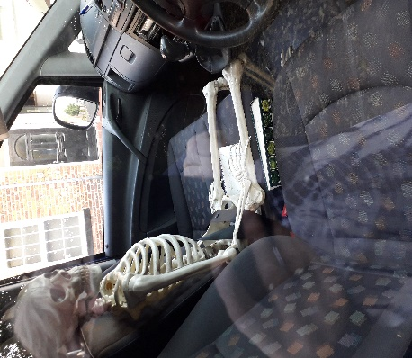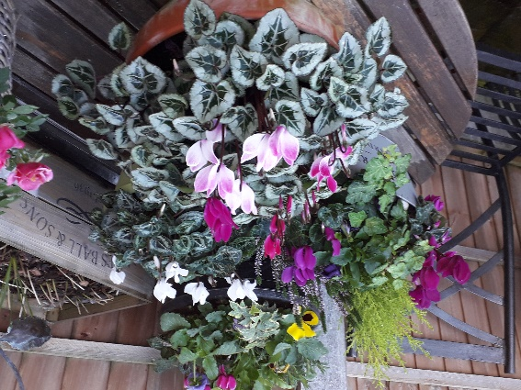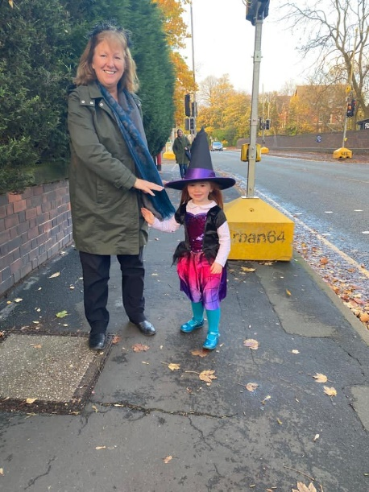**Photo gallery**

Spotted by Janine - Missed too many lunchbreaks?

Elaine’s” witchy” Grandaughter.

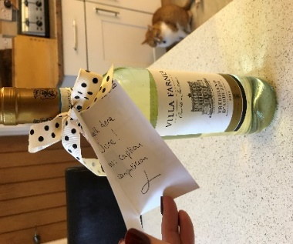

A colourful winter display by Janine

Our next edition will be a Christmas Edition.

**Contributions in by 10th December please.**

[sianrc@hotmail.co.uk](mailto:sianrc@hotmail.co.uk)

June’s prize for the September caption competition.

!

.

!