

COMBERBACH WI RAMBLINGS February 2021. Edition 11

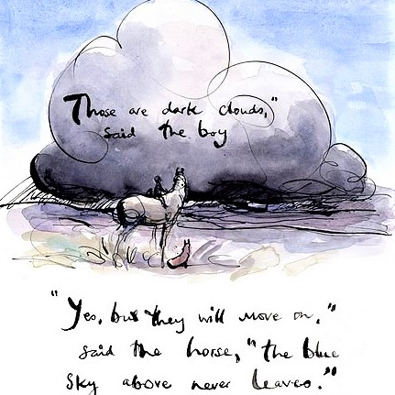Janine’s Jottings

Christmas has now disappeared into a distant haze and I am glad to say that we have seen the back of January. I hate January. It is the big let-down after Christmas, cold, wet and still dark at the times when I would prefer it to be light. It certainly lived up to the cold, wet and dark, but at least we were spared flooding, despite the town being affected. The one positive amongst it all has been the little pot of crocuses, which has bloomed continuously throughout the month with both yellow and lilac flowers, brightening the grey days and has only just finished. I have now put the pot outside to die down, ready for another year.

I approached February with greater positivity, being grateful for more light in the mornings and evenings and pleased to note the appearance of bulbs in my garden. I just hope they don’t rot with all the rain we keep getting, as I am looking forward to seeing the flowers again. It reinforces the fact that despite everything, Spring will arrive!

I have now had my first Covid vaccination, along with several of our WI ladies. They seem to be well organized up at Kingsmead, and I spent my obligatory 15 minutes wait afterwards in the “Promoting Sexual Health” tent, which passed without me feeling any ill effects.

This moves us all that little bit closer to being permitted to do more – but the Committee and I still cannot see us being able to hold WI meetings any time soon. What we might be able to do in the Spring is the resumption of outdoor meet ups, say, in Marbury, with a flask, or coffee “clusters” in gardens. If all goes well, we might be able to have larger groups outdoors or even a garden party – we can only hope. Depending on how restrictions are lifted, we might even be able to have a local pub lunch…. Speaking of food, I did contact Louise, to see if we could re-book the Christmas meal at Winnington. I haven’t had a reply, so will try again. Lindsay suggested a Tasty Evening instead if we can’t go ahead with Winnington. We shall have to wait and see…

In my spare time I have watched a fair amount of TV, enjoying the “Pottery Throwdown” on Channel 4, and “Landscape Artist…” on Sky Arts, which you can get on Channel 11.

I have also finished embroidering the WI bag and baked scones. The scones did not come up to expectations, so baked some more the following day and this time I remembered to include the baking powder I had previously omitted, as I had used plain flour. The birds enjoyed the first batch! I also found time to sort out my wardrobe and discard a few items.

You will have by now probably heard that the WI will not be involved in any Cheshire Show activities this year, so that decision tells me plenty about the WI’s stance on the resumption of meetings and activities.

With that news, I used the jar of apricot jam which I had made especially for the show, as no-one will want to judge a two-year old jar of jam next year. It was good and the lid came off the obligatory “pop”. I think I would have gained a decent mark for it. Oh well, never mind… You will also find in this edition of “Ramblings” a number of items which have been passed on to us from NFWI/CFWI., so if you want some ideas for lockdown, read on….

Stay safe everyone - we will get through this! Janine.



Janine is pleased to report that the embroidery on the bag is finished. Certain images on the bag do not lend themselves to being fully stitched, so have tried to reach a happy medium...

*Isn’t it beautiful? Has anyone else had a go at embroidering the Centenary bag- if so lets share!*

______________________________________________________________________________

Update from Sara

As you have no doubt heard (several times) vaccinations are going well so I presume quite a few WI members are now feeling a little less vulnerable. It may be a while however before we can start meetings again but the committee are ready to start planning as soon as we are able.

In the meantime, I am sure you have all been busy, making things, cooking, gardening or just getting through all the books you have not read. I have started practising my oboe again and done a couple more paintings.

We have had a bit of correspondence from NFWI and I believe most of it has been forwarded to you all via email. If there is anything, I mention that you would like details of do not hesitate to ring me.

If you have read any of the correspondence you will know that the Annual Meeting at The Albert Hall is to be held on the 8th June this year but with a limited capacity. More details later.

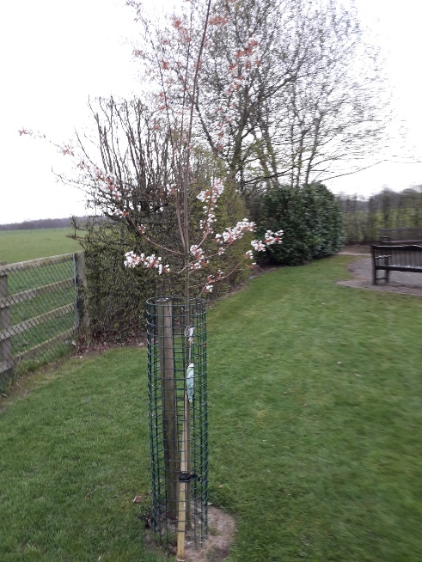Sian is busy putting together our archives for submission and I have sent them details and location of our Centenary Tree which we planted. Someone is compiling a list of these in case any members want to tour round to look at them when lockdown eases. This is our tree Spring 2020

**LADY DENMAN CUP COMPETITION**.

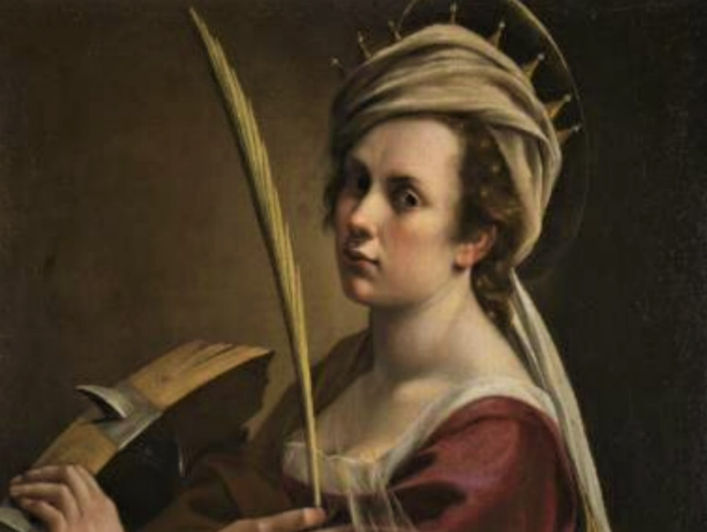

You should also have been sent details of the Lady Denman Cup Competition for any budding writers out there. You have been asked to submit in no more than 500 words a piece of writing of

fact or fiction in any style based on a painting by Artemesia Gentileschi. This needs to be submitted by the 30th July and I have a copy of the entry form if any of you are interested.

You should also have received your WI Life magazine by now wherein there are details of the NFWI Board Elections. If after you have read through the details of the candidates and you wish to contribute your suggestions, do not hesitate to contact me and I will pass your preferences etc onto the committee before we fill in the voting form.

Keep crafting etc and if you need to contact me my details are as follows:-

Email:- [saram.smith@yahoo.com](mailto:saram.smith@yahoo.com) <Tel:-> 01606 891 612

_____________________________________________________________________________________________

**Cheshire Federation of Women’s Institutes “Crafty” Lockdown Challenge**

You may have seen a reference in recent correspondence from the CFWI about the Scarf Challenge. We were a little confused as to exactly what the challenge entailed, so after speaking with the organiser, Susan Leicester, CFWI Arts & Crafts sub-committee we can now explain it to you all.

The idea is to knit or crochet scarves of about 6 inches x 6 feet and donate them to a charity of our choice. In order to make this task a little more interesting and challenging, it is suggested we nominate a local landmark or local interesting feature, measure it – then work out how many scarves we need to knit to achieve that measurement and get knitting.

For example, one WI has chosen their local church spire – found out its height and are now challenging themselves to knit the distance in 6’ scarves. Sandiway WI are using the circumference of the Sandiway Tower as their goal….

We have passed on the information to our Craft group for their opinion, but if in the meantime if you have any ideas as to which feature we could base this challenge on please let Sian or Janine know.

One suggestion has been the Marbury Lady recently carved out on the edge of Marbury Park. She is nice and tall and would be an excellent choice – but we will await to see if there are any other suggestions. In the meantime, if you want to start knitting 6’ long scarves – feel free to get those needles clicking! We also need to nominate a local charity to which we would like to donate the scarves to later on in the year.

We would keep the CFWI informed of our challenge and progress with stories and pictures, and ultimately the CFWI will post the total length achieved by all the participating WIs and work out how far we could go from WI House in Chester with the length knitted by all the participating WI’s. It would be a great local interest story too!

This challenge will run till the end of the year, but the sooner we get started the easier it will be!

______________________________________________________________________________

**Dear Members. (Heather Morris)**

I have enjoyed chance meetings with a few W.I members when out walking locally and speaking to some on the phone.

Motivation is a bit hit and miss for me at the moment. I am embarking on a project currently however. Our eldest daughter will be 40 in April so I am selecting photographs of her childhood to compile an album for her. Well this is proving more of a task than I originally envisaged as my predigital 1981 family photos were in packs in a box in the loft and not in any way catalogued.

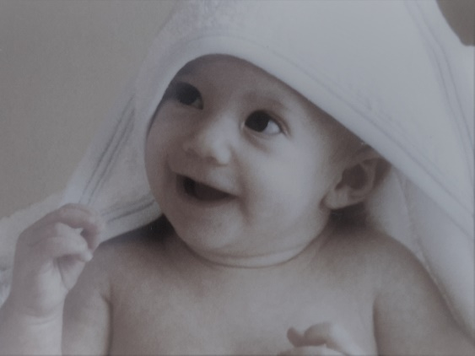My husband has always had an interest in photography and taken some lovely photographs and slides. Our slide projector purchased in 1982 refused to respond to cog repairs so he purchased a digital film scanner so that we can digitise the slides.

I haven’t started selecting photographs taken with the digital camera yet. Masses of images are stored randomly on the computer! I will need focus and stamina for sorting through them.

This ramble is not really about completing a task but the experience you gain when you engage in an activity. Going through this process has emphasised the importance of our own family history and we have enjoyed reflecting on times past. I have a deadline of the end of April to produce the album and with help from Dave I look forward to sharing these family memories with my children and grandchildren.

**Best Wishes to everyone. Regards Heather Morris**

----------------------------------------------------------------------------------------------------------------------------------

**Lockdown Projects by Miriam Manners**

In May of 2020 I decided to use the lockdown to try and improve my photography, as most of you already know a camera is nearly always with me ready to catch the moment, but I needed to take this further.

I already belong to Frodsham Photographic Society based in Frodsham and this has been a great help with all things photographic. It's also a great way of meeting likeminded people. But I needed more so I joined the Guild of Photographers in May 2020, though everything is done on-line it’s had been a great way to push my work forward, every month you can submit pictures and these

are judged by international judges not one but five and you get your results ranging from nothing-classified-bronze-silver and gold.

I have managed quite a few bronzes in the seven months I have been submitting my work and I am really pleased with that, my aim is to just get better, a long way to go as the standard is very high.

I did succeed in getting my Qualification though. One of the competitions was called The Founders Cup. For this I had to submit 3 Prints which had to be connected in some way. I was very lucky to get into the Last Ten but sadly not the winner, the pictures were of seed heads taken from the garden and were in Black & White

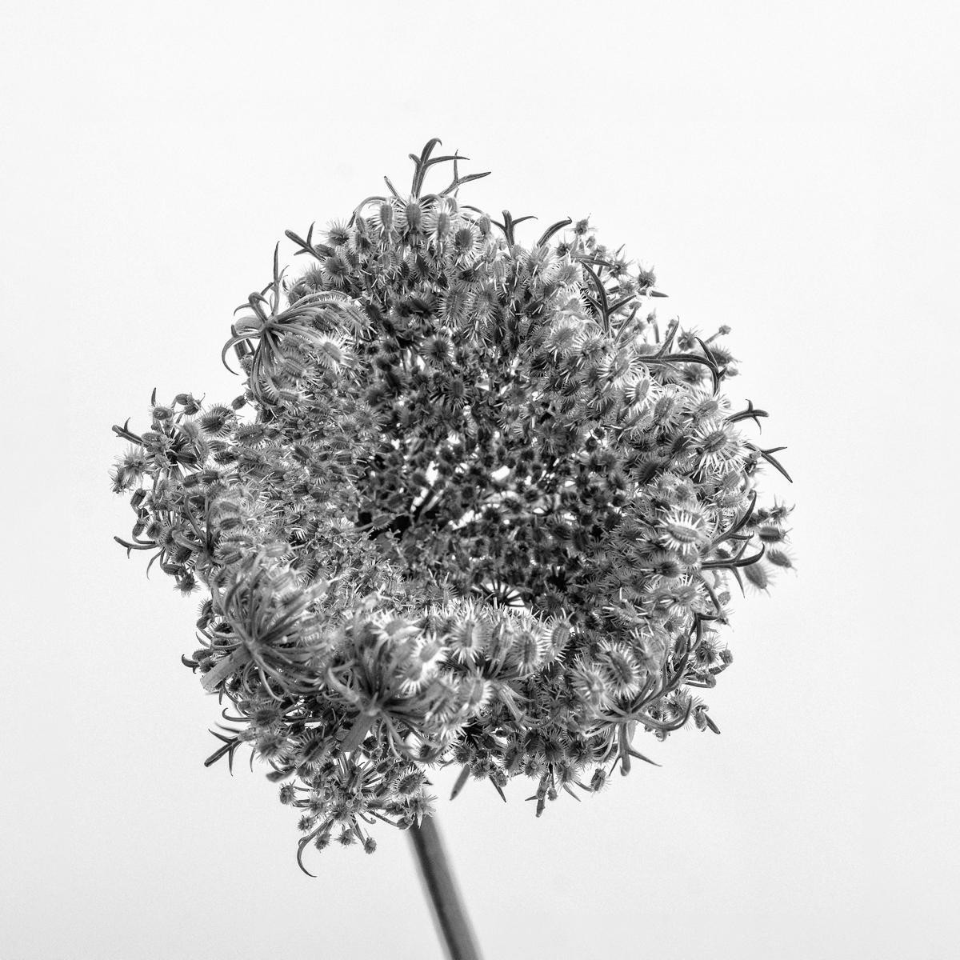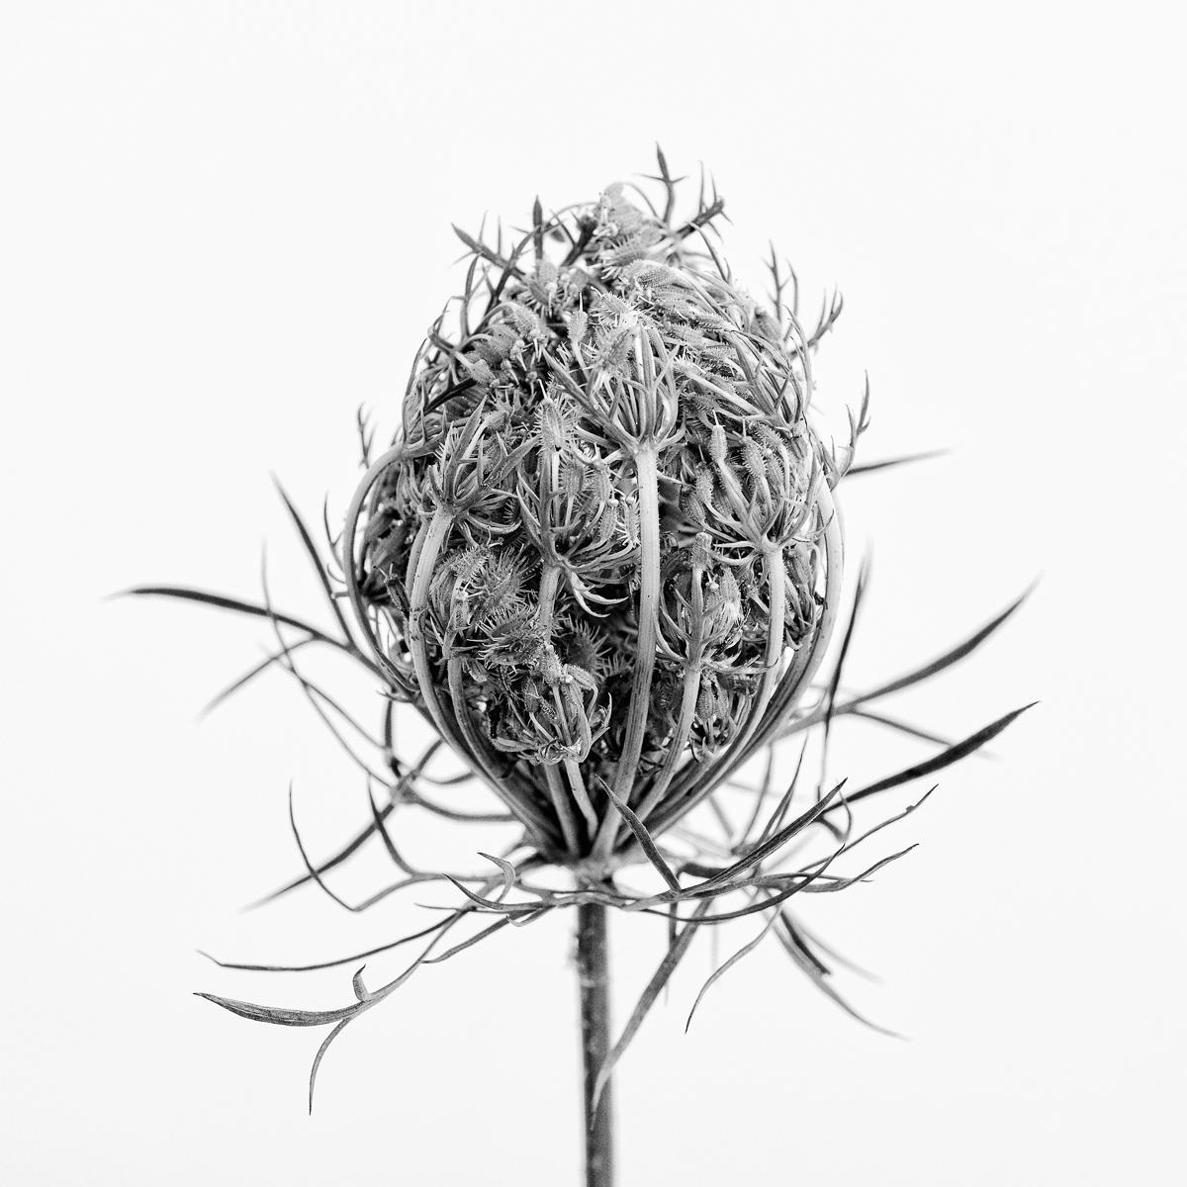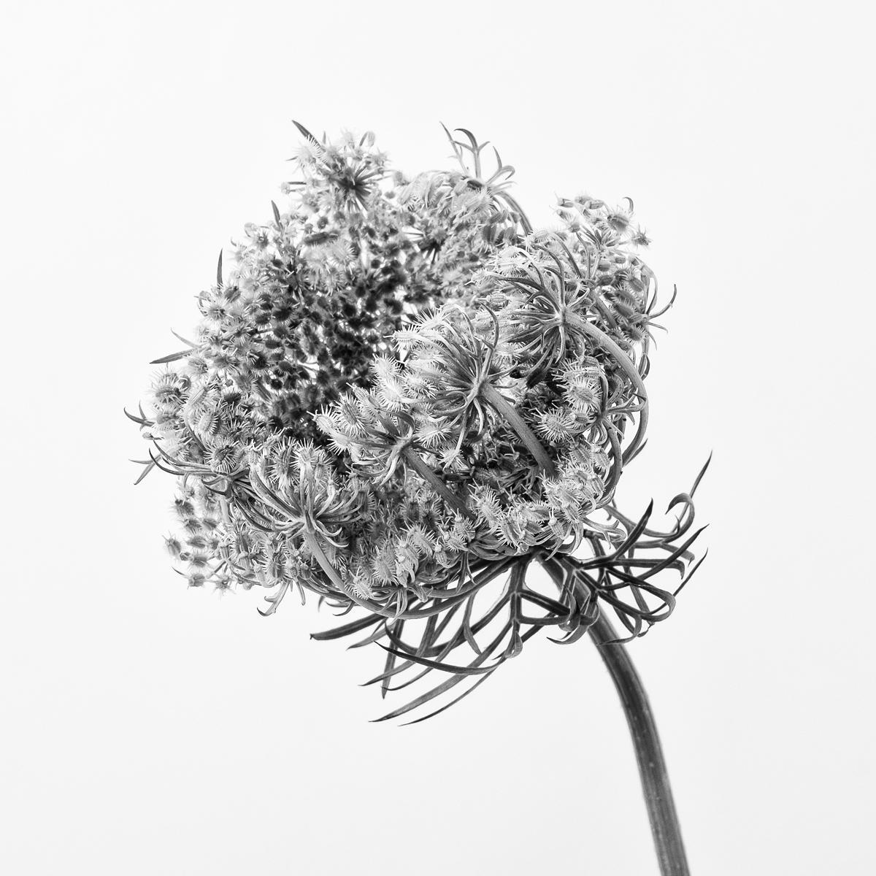Foundation Cup Finalist

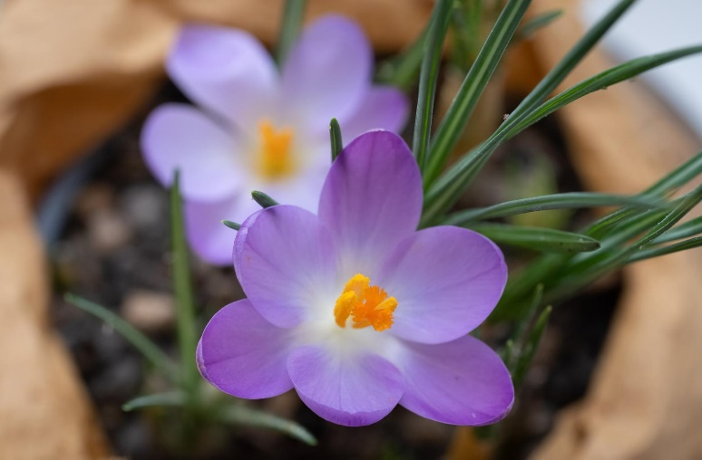

I would also like to thank Comberbach WI for the lovely Crocus and here is my picture. A big thank you to Sian for all the work she puts in putting Ramblings together.

Wishing you all a Very Happy & Healthy New Year please stay safe, looking forward to meeting up again very soon.

If you would like to see some more of my work, I now have a web site with other links - **Badmanners.me.uk**

---------------------------------------------------------------------------------------------------------------------------------

***A new Hip for Sian in 2021!***

As some of you may be aware, I have recently had a new Hip! Having gone through the rigorous pre-operative test and Covid precautions in weeks running up to the big day,

I arrived at Spire Cheshire very early on the morning of January 13th and had a new hip joint in place by 11am! I had a Spinal Anaesthetic, and although it was a little unnerving being aware of my surroundings and noises – it was an amazing experience – and I can assure you that I did not feel a thing and it was great not to suffer any of the after effects of a general anaesthetic. Safely and snuggly tucked in my electrical controlled bed back in my room, I was more than ready to enjoy a cup of tea and a sandwich at lunch time. The day seemed to fly by, the nurses and ward support staff were so attentive and caring. By supper time I was tucking into a delicious fish pie and all the trimmings. As the spinal anaesthetic wore off, I had a very pleasant cocktail of pain relief tablets and I managed to sleep well.

Day one started early with a welcomed cuppa at 6am and then put my contact lenses in, tidied my hair, applied a little make up by the time the day staff came on duty at 8am, oh I also managed to reapply the nail polish which had to be removed before I was allowed in the operating theatre. I think I peaked a little early that morning – as I spend the rest of the day dozing on and off – With a brief interlude when the Physiotherapy arrived and went through the exercises I needed to concentrate on three to four times a day – and to help me get out of bed. After getting over my slight nervousness of whether the new hip would stand my weight – I managed to stand up quite easily and take a few steps around the room using a walking frame. It was great to know it was all in good working order and the pain was minimal.

Day two was about enjoying a shower and walking a distance along the corridor using two crutches. I was also dared to try walking down and up a flight of stairs. Again, the thought of doing this was much worse than the action. The Physiotherapist was very patient and careful and I was really pleased that it was much more straight forward than I had anticipated. I was signed off as being fit for discharge – so my dear husband was able to collect me on Day 3. It was great to be home, once again a little daunting, but its all worked out very well. Richard took charge of all domestic issues for the first week or so. I got up and dressed each day and pottered around, giving helpful advice and words of encouragement, as I saw it, not sure if Richard saw it that way!!

It’s now over a month since the operation and I am getting on very well indeed. This morning I walked from home to the Comberbach post office and back, still using the two crutches for distance walking, but managing to potter around the house with either one or no crutch. I aim to be back to normal activities within three months – so that’s now only two months away! So by early April I should be able to be ‘normal’ again – and get back on my bike, and get the garden tidied for Spring.

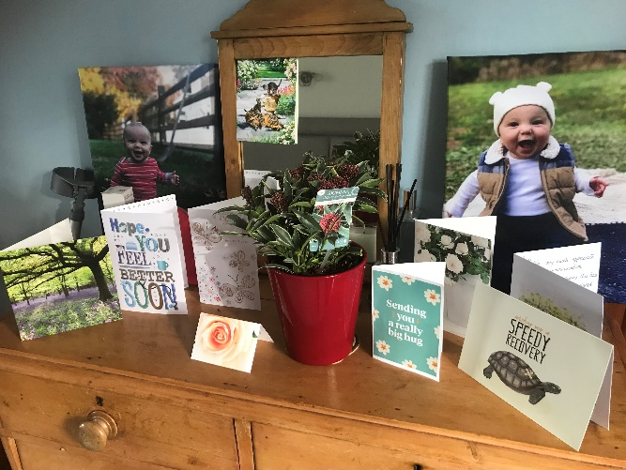In normal times foreign travel would once again be high on my list – but as its now illegal to go abroad – heaven knows when we will be able to get over to the USA to spend time with our son and family.

If anyone would like to chat to me about my experience further, I am happy to share my journey, whilst it’s all fresh in my mind. As so often is the case – the thought and anxiety of these sort of operations are far worse than the actual experience. There have been a few ‘not so good’ points’, but lets not dwell on them!!

I would like to thank members for their kind wishes, flowers and cards.

It’s been much appreciated. Sian xxx

I found that these shrubs have flowered whilst I was immobile,

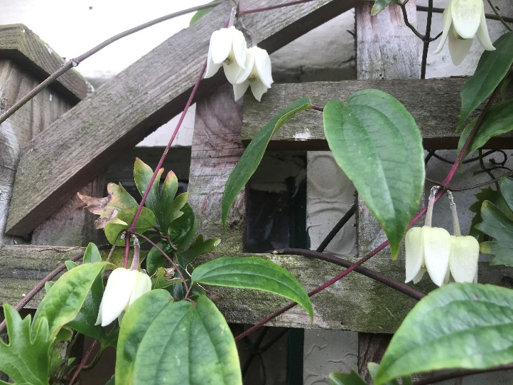

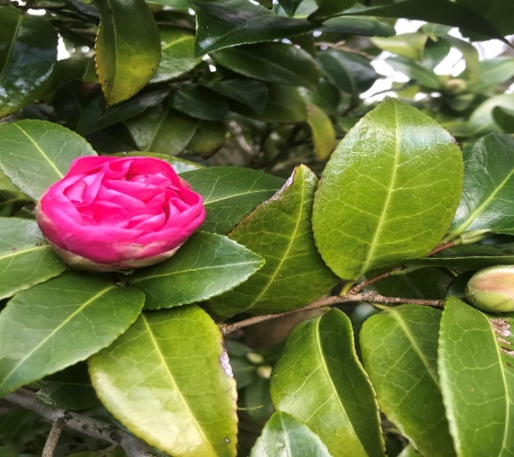Against all odds – frost, ice, rain, sleet and snow in full bloom now - Clematis Winter Beauty also known as Urophylla Winter Beauty. What a delight.

Camellia – don’t know the type name

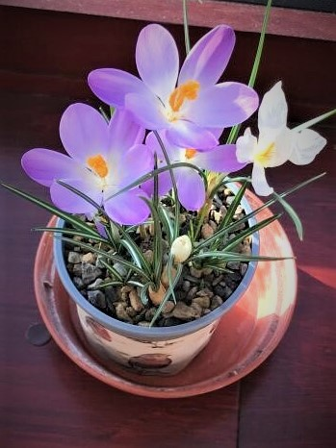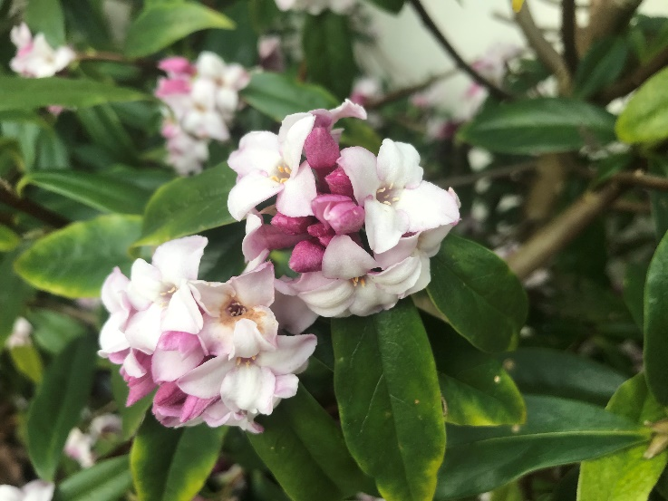

1Margery Hall’s crocuses

Daphne Odora, exquisite fragrance

______________________________________________________________________________

**Below are the links for Cheshire Federation Zoom February 2021**

**On Thursday the 25th February at 7pm for a 7.30pm** start we have the pleasure in welcoming Katie Awdas talking about Living with Endometriosis. It is thought that around 176 million girls and women suffer from endometriosis worldwide. Katie has suffered from the chronic condition endometriosis since the age of 16, taking ten years to receive a diagnosis, and is now in her early thirties. She will talk to us about her ongoing battle with this debilitating and painful condition while trying to lead as normal a life as possible, a challenge which may well resonate with many of you. Katie stepped out of her comfort zone and joined 11 other women in making a calendar for Endometriosis UK, as Miss June, with 100% of the profits being donated to the charity. See link below:

https://us02web.zoom.us/j/82035381166?pwd=bU1YM2J3em9EQ0txbXR5aEg3THdkdz09

Meeting ID: 820 3538 1166 Passcod 463006

**On Tuesday the 9th March** at 7pm for a 7.30pm start we have the pleasure in welcoming Toto James. Toto was co-opted to the Board of Trustees in November 2019. She is also Vice Chairman and a Trustee of Surrey Federation, as well as Head of Digital. Toto was honoured as a Women of the Year in 2018 for her professional work as a Marketing Consultant for a leading law firm and her charity work. Toto will talk about her life in the W.I. and what made her join in the first place and why her Indian parents and their sense of community has led to her aspirations for a WI that reflect our communities.https://us02web.zoom.us/j/87485533623?pwd=Smh5YU1wVGNxMml5Sm9WQXlOd2EzZz09

Meeting ID: 874 8553 3623 Passcode: 83525 l

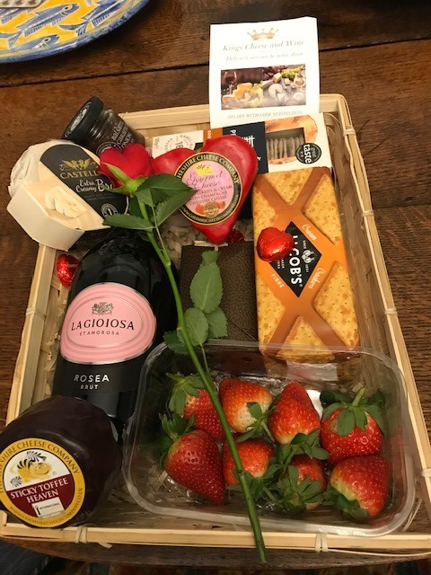Lucky win for Lindsey  
I have won the raffle run by Kings Cheese and Wine to raise money for the Northwich floods. They are a new on line firm in Northwich who deliver and also do a lot for charity. As you can see it’s full of great goodies.

Info@kings cheese and wine.co.uk  
07809109524

*Please send any snippets, short stories, photos, poems, reviews, poems or anything you would like to share with your fellow members by the 10th March 2021 for the next edition of Ramblings…. to* [*sianrc@hotmail.co.uk*](mailto:sianrc@hotmail.co.uk) *07770863170 / 01606 892157*